My eye

We use our eyes to see.
The black dot in the middle is called a pupil.

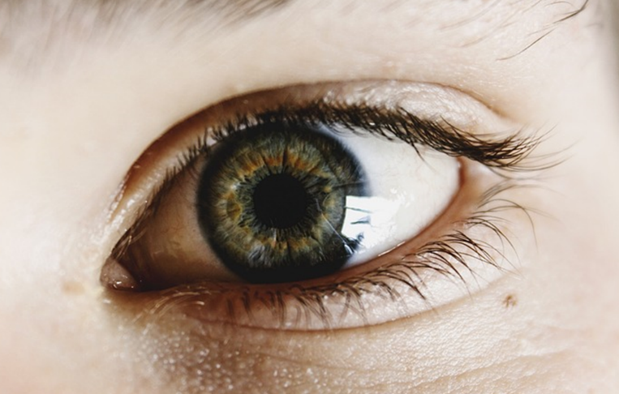

Which part(s) of our eye can detect the light we see?
Which of these statements do you think are right?
For each statement, tick (✓) one column to show what you think.
Places |  | I am sure this is right | I think this is right | I think this is wrong | I am sure this is wrong
A | The pupil is a hole light can go through
B | The pupil can detect light
C | The back of the eye can detect light

Physics > Big idea PSL: Sound, light and waves > Topic PSL2: How we see > Key concept PSL2.1: The ‘passive eye’ model of vision
Diagnostic question
My eye

Overview
Learning focus: | Objects are seen when light reflects off them into our eyes.
Observable learning outcome: | Describe the pupil in an eye as a hole that light can go through.
Question type: | Confidence grid
Key words: | Pupil

P | PRIOR UNDERSTANDING  This diagnostic question probes understanding of ideas that are usually taught at age 5-11, to aid transition from earlier stages of learning.

What does the research say?
Optics instruction often takes for granted the essential fact that light must enter the eye for vision to take place. The need to convince the learner of this is seldom recognised (Galili and Hazan, 2000). This can be as simple as observing that the pupil in the eye is actually a hole that light can pass through (Gonzalez-Espada, 2003; Hardman and Riordan, 2014).
Ways to use this question
Students should complete the confidence grid individually. This could be a pencil and paper exercise, or you could use an electronic ‘voting system’ or mini white boards and the PowerPoint presentation.
If there is a range of answers, you may choose to respond through structured class discussion. Ask one student to explain why they gave the answer they did; ask another student to explain why they agree with them; ask another to explain why they disagree, and so on. This sort of discussion gives students the opportunity to explore their thinking and for you to really understand their learning needs.
Differentiation
You may choose to read the questions to the class, so that everyone can focus on the science. In some situations it may be more appropriate for a teaching assistant to read for one or two students.
Expected answers
Answers A and C are correct.

How to respond - what next?
A significant number of students are not aware that the pupil is a hole through which light can enter the eye.
Nowadays many opticians routinely take a photograph of the back of the eye (a retinal photograph) on each visit. Some students are likely to have had such a photograph taken, and you can encourage them to share their experiences with the class. This will open discussion about the nature of the eye’s pupil and allow students to make a connection between science and their everyday lives.
The word pupil comes from the Latin word papilla which means little girl or doll. If your students look at each other’s pupils carefully, then they should be able to see a small reflected image of themselves. They should also be able to see that the pupil is in fact a hole.
Online videos and pictures can be found that show how retinal photographs are taken. The camera looks into the eye through the pupil.
Acknowledgments
Developed by Peter Fairhurst (UYSEG)
Images: Pixabay (CCO Creative Commons)
References
Galili, I. and Hazan, A. (2000). Learners' knowledge in optics: interpretation, structure and analysis. International Journal of Science Education, 22(1), 57-88.
Gonzalez-Espada, W. J. (2003). A last chance for getting it right: addressing alternative conceptions in physical sciences. The Physics Teacher, 41, 36-38.
Hardman, M. and Riordan, J.-P. (2014). How might educational research into children's ideas about light be of use to teachers? Physics Education, 49(6), 644-652.

